**Agricultural Market Price Dashboard using Excel – Documentation**

**1. Data Preparation**

**Dataset Overview**

* **Source**: Agricultural market commodity prices (State, District, Market, Commodity, Variety, Grade, Arrival Date, Price metrics).
* **Date Range**: Single day – 05-06-2025.
* **Fields Included**:
  + State, District, Market
  + Commodity, Variety, Grade
  + Arrival Date
  + Min Price, Max Price, Modal Price

**Data Cleaning Steps**

* **Blank Cell Check**:
  + Used filters and Go To Special → Blanks to ensure **no missing values**.

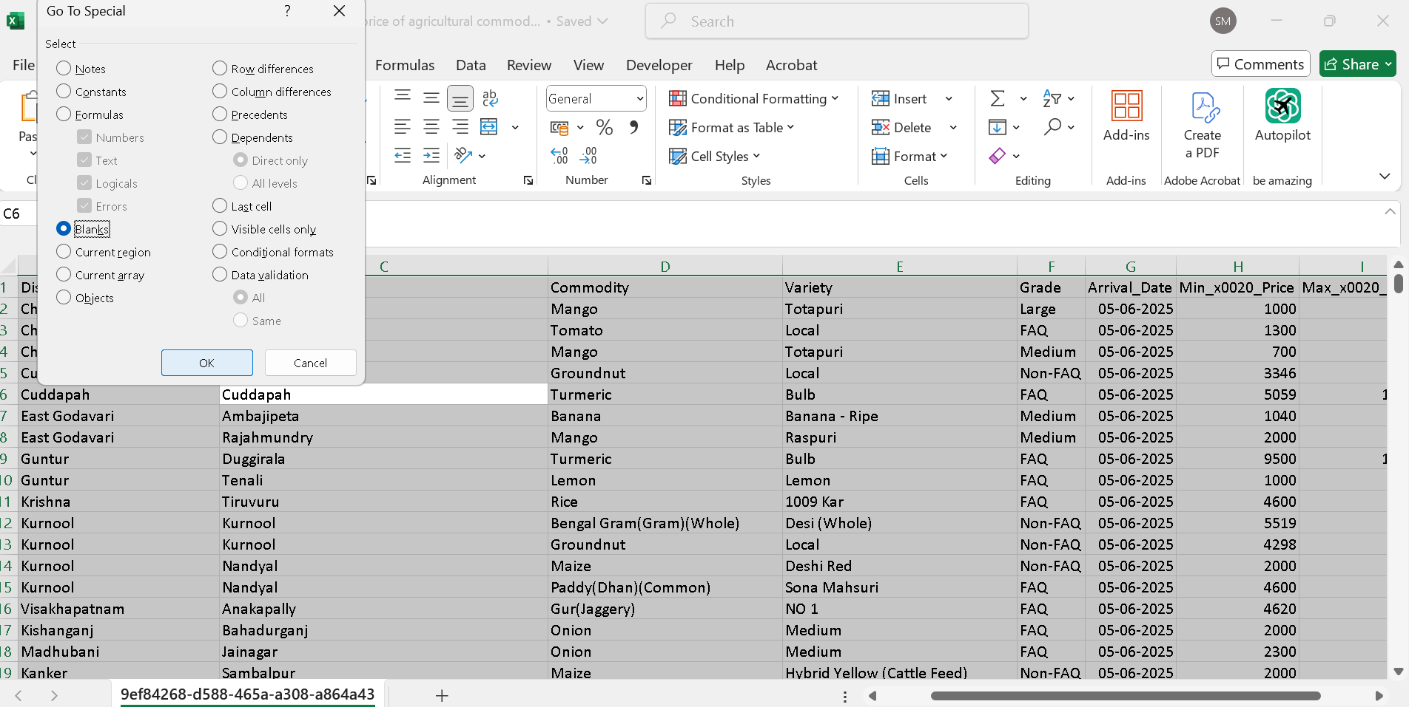

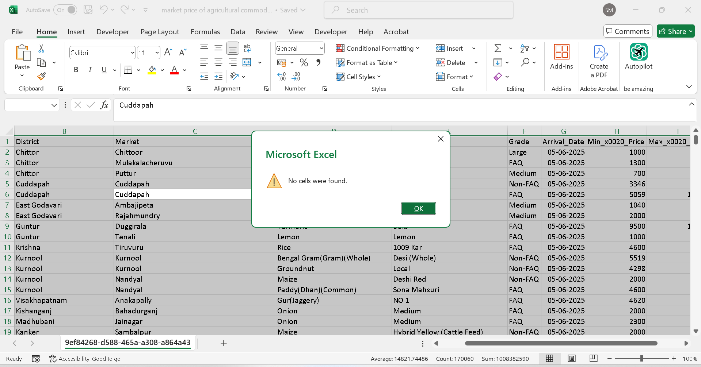

* **Duplicate Check**:
  + Applied Remove Duplicates on the entire dataset – **no duplicates found**.

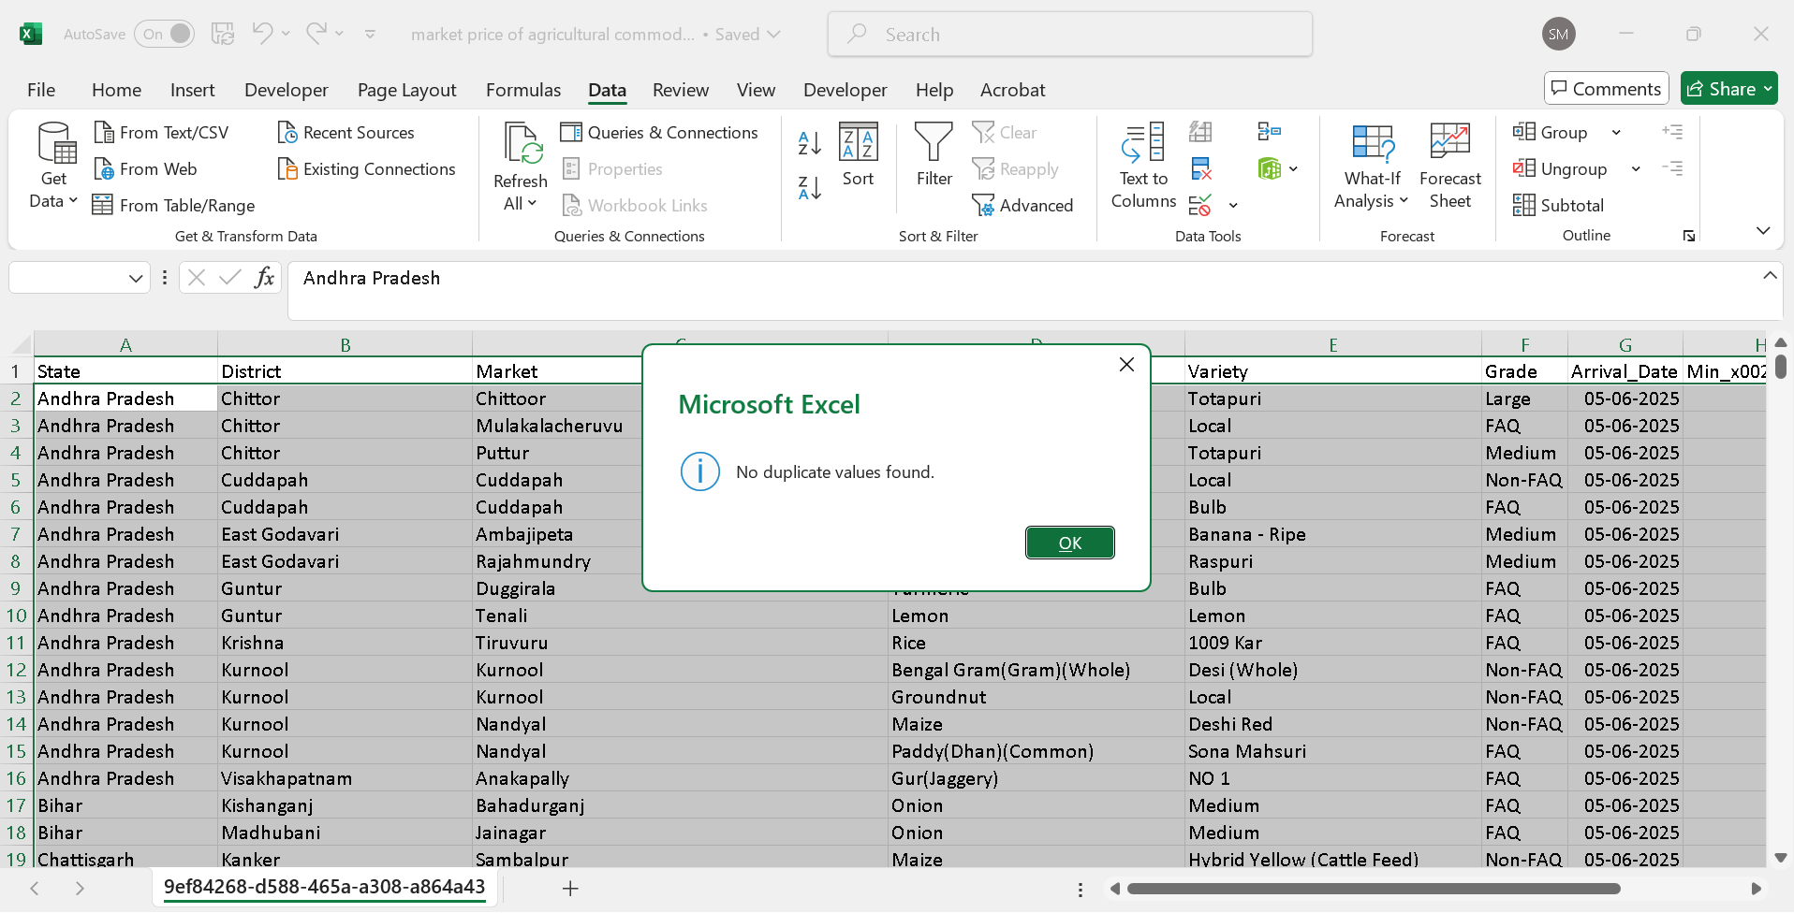

**Column Headings Renamed**:

* + Replaced names like Modal_x0020_Price with clean, readable names (e.g., Modal Price).

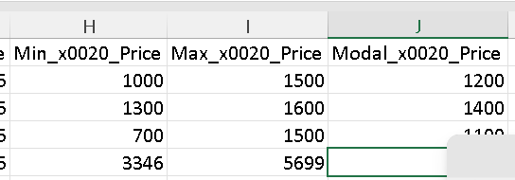

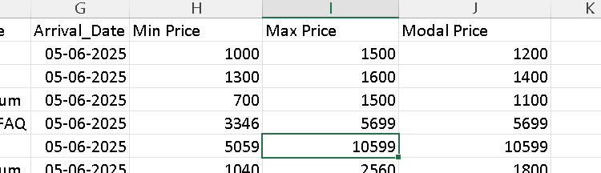

**Named Range Created**:

* + Defined the entire cleaned dataset as a **Market Data**

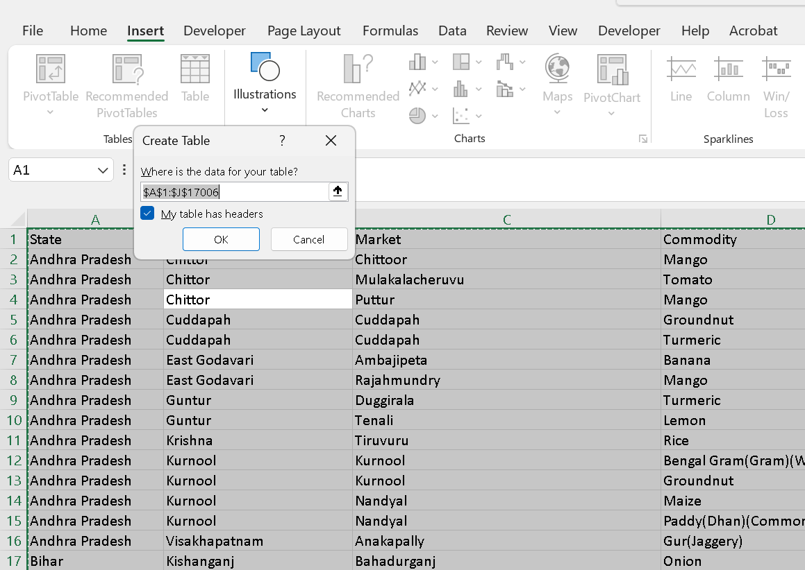

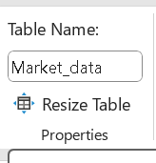

**2. KPI Summary Cards**

**Tools Used**

* Shapes (Insert → Illustrations → Shapes) to create **KPI Cards**
* Formulas directly written inside the shapes for dynamic values
* Named table (MarketData) for easier formula reference

**KPI Formulas Used**

| **KPI** | **Formula** |
| --- | --- |
| **Total Commodities** | =COUNTA(UNIQUE(MarketData[Commodity])) |
| **Total Markets** | =COUNTA(UNIQUE(MarketData[Market])) |
| **Average Modal Price** | =ROUND(AVERAGE(MarketData[Modal Price]), 2) |
| **Highest Max Price Commodity** | =INDEX(MarketData[Commodity], MATCH(MAX(MarketData[Max Price]), MarketData[Max Price], 0)) |

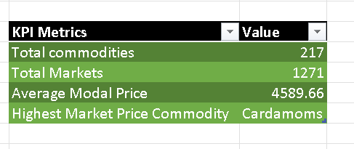

**3. Charts & Visual Analysis**

**Category Comparison**

***A. Modal Price by Commodity***

* **Pivot Table**:
  + **Rows**: Commodity
  + **Values**: Average of Modal Price

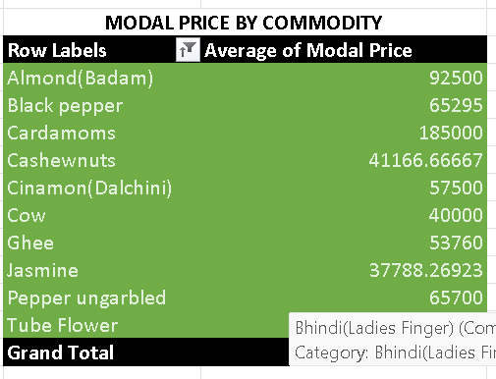

* **Chart Type**: Clustered Column Chart

***B. Count of Commodities***

* **Pivot Table**:
  + **Rows**: Commodity
  + **Values**: Count of Commodity

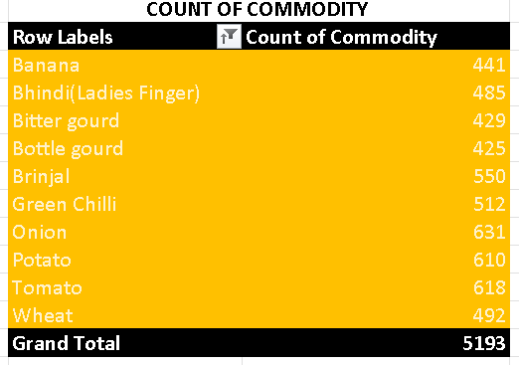

* **Chart Type**: Horizontal Bar Chart

***C. Price Range by Commodity***

* **Pivot Table**:
  + **Rows**: Commodity
  + **Values**: Sum of Min Price, Modal Price, Max Price

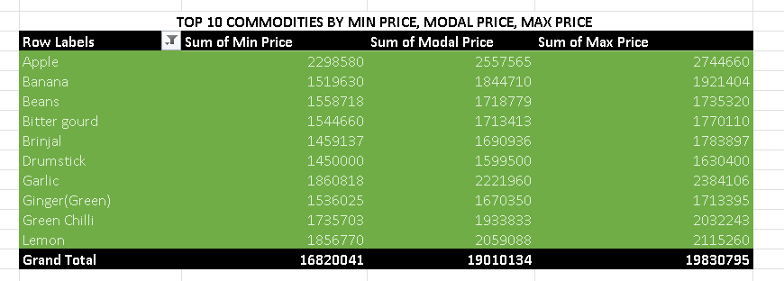

* **Chart Type**: Stacked Clustered Column Chart

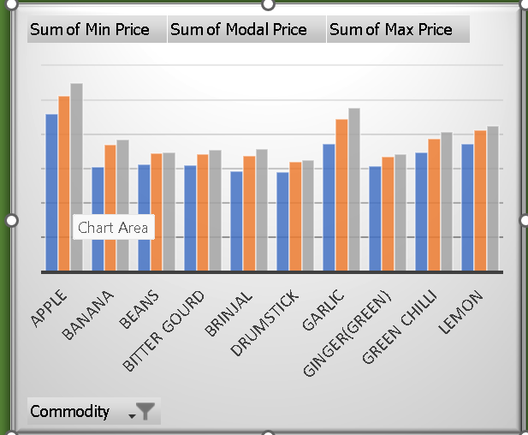

**Market Distribution**

***D. Market Count by Grade***

* **Pivot Table**:
  + **Rows**: Grade
  + **Values**: Count of Market

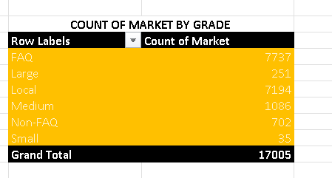

* **Chart Type**: Pie Chart

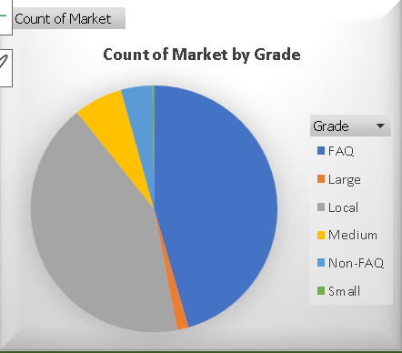

**Conclusion**

This Excel dashboard provides a comprehensive view of market prices, enabling stakeholders to:

* Monitor price trends
* Identify high-value commodities
* Track distribution by grade and market
* Compare price ranges across commodities

